Test direction: functional test

Developed the ‘Recruitment Notes’ software, completed several basic functions, manually tested it, entered some data to record the test, the record was successful, and can be viewed.

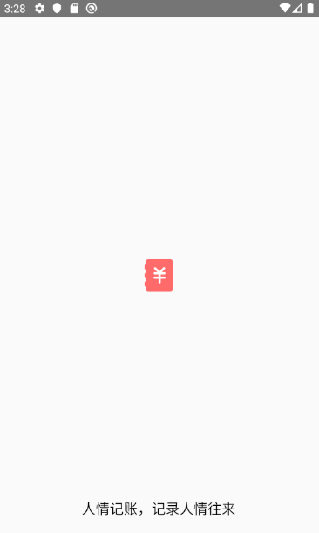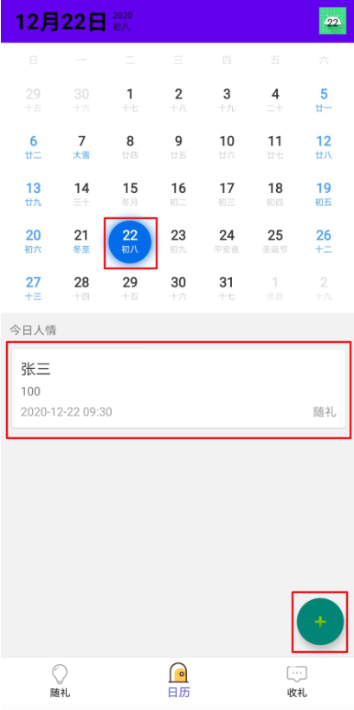

Open the APP and enter the main interface. The main interface is the calendar. You can click to select a day, and the record of the day's added'with gift' or'gift' will be displayed at the bottom; then click the'plus' sign in the lower right corner to enter the adding interface, Add a gift or receipt record on the day.

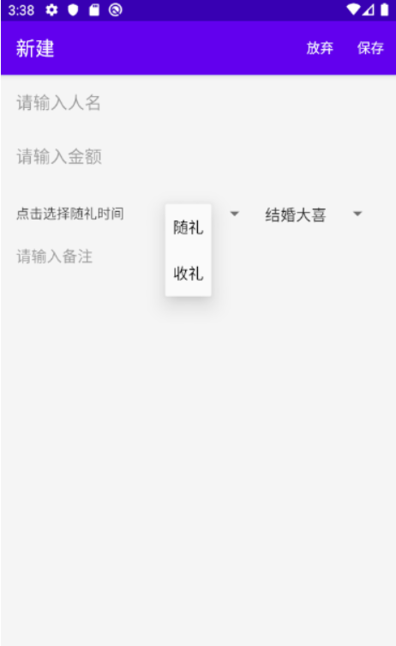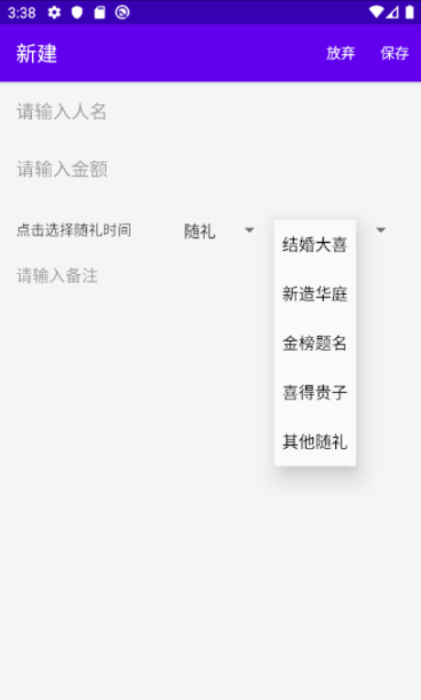

Type

After entering the add interface, enter ‘person’s name’, ‘amount’, select ‘time’, ‘with gift’ or ‘receive gift’ and ‘type’, and click ‘save’ in the upper right corner after completion.

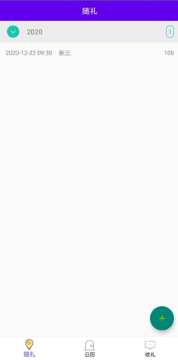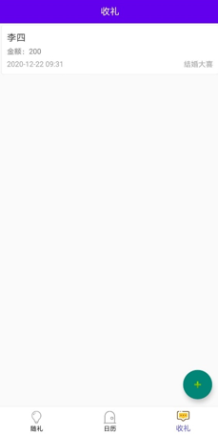

The left interface displays all the information recorded by the user.

The right interface displays all the ‘gift receiving’ information recorded by the user.

Test Data

|  |  |  |  |  |
| --- | --- | --- | --- | --- |
| Name | Amount | Time | With gift/receiving gift | Type |
| A | 888 | 2020/12/21 | With gift | marry |
| B | 666 | 2020/12/22 | With gift | New house |
| C | 866 | 2020/12/23 | receiving gift | Nominated |
| D | 688 | 2020/12/24 | receiving gift | Baby boy |

